- Consider the following star system.
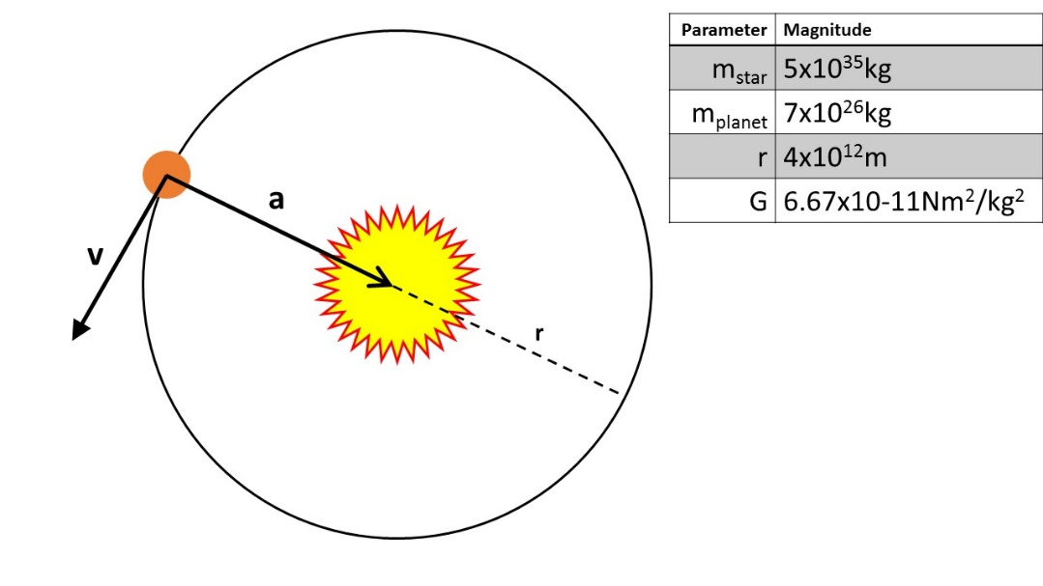
5x10³¹kg
- Find the gravitational attraction between the star and the planet.

- Use your answer in (a) and Newton’s 2nd law of motion to find the planet’s centripetal acceleration.

- Use your answer from (b) to find the kinetic energy of the planet.

- Use your answer from (c) to find the planet’s gravitational potential energy.

- How far would the planet need to be for the gravitational force to be ¼ of its value from answer (a)?

- What is the planet’s centripetal acceleration at the distance you calculated in (e)?

- Consider the following scenario:
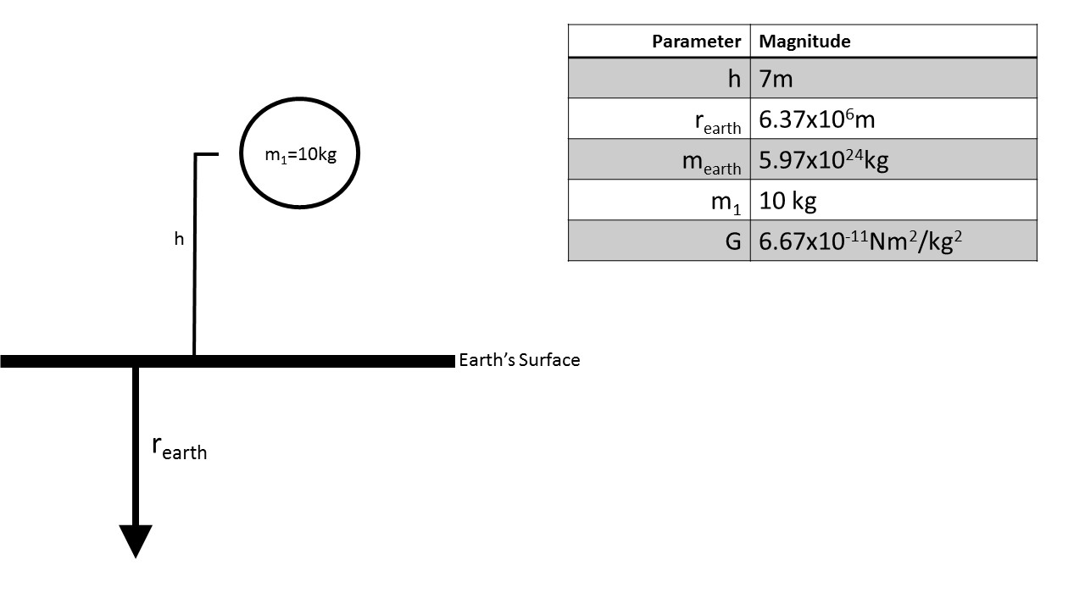
- Calculate the gravitational force between the ball and the Earth.

- What is this force also known as?

- Use your answer in a to find the acceleration of the ball when dropped.

- What is this acceleration also known as?

- Use your answers in parts (c) & (d) to find the ball’s gravitational potential energy at height “h”.

- What is the magnitude of the ball’s kinetic energy when it hits the Earth (neglect air resistance)?

